BRIDAL REGISTRY

Name: Megan Collier Groom: Riley Mott
Wedding Date: November 14, 2020
Phone: Email: megpcollier@gmail.com
Pick up or Ship Gifts? Pick-up
Contact Info: contact MOB (Cailin) for pick-up
__________________________________________________________________
Qty Needed | Item # | Description | Cost
3 | 7353 | Juliska Berry & Thread/French Panel Whitewash 4 pc place setting (Berry & Thread dinner, French Panel salad, pasta and cereal bowl) | 158 | 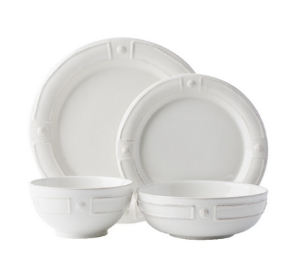
8 | 7355 | Juliska Berry & Thread French Panel side/cocktail plate | 24 | 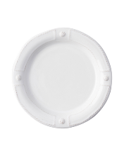
2 | 7354 | Juliska Berry & Thread Whitewash Mug | 32
1 | 7356 | Juliska French Panel 11.5” serving bowl | 72 | PURCHASED
1 | 7373 | Juliska Berry & Thread 9.5” Serving Bowl | 62 | PURCHASED
6 |  | Juliska Berry & Thread Berry Bowl | 30 | 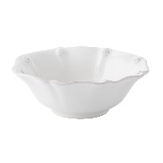
4 | 7371 | Juliska Berry & Thread Footed Soup Bowl | 32 | PURCHASED
1 | 7357 | Juliska French Panel 16.5” Platter | 95 | 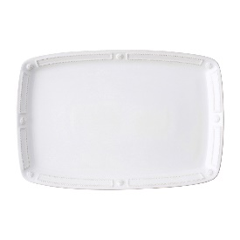
1 | 7358 | Juliska French Panel 17” oval baker | 95 | PURCHASED
1 | 7369 | Juliska Berry & Thread Charger | 78 | 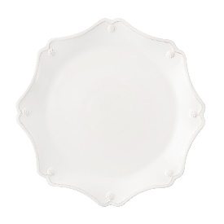
1 | 7359 | Juliska French Panel Handled tray/platter 19” | 160 | 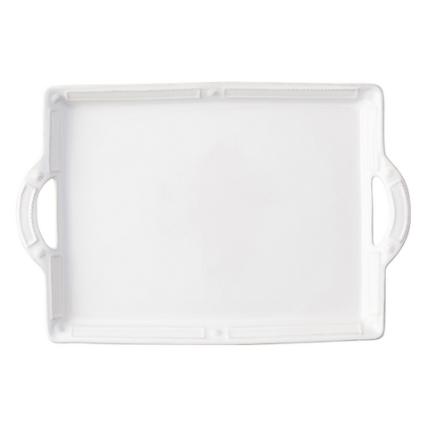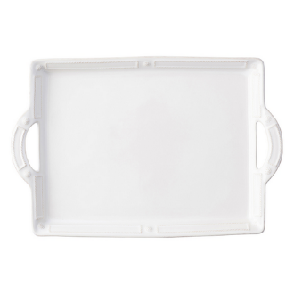
1 | 7369 | Juliska Berry & Thread 16” Oval Platter | 95 | PURCHASED
1 | 4108 | Simon Pearce Woodbury large pitcher | 160 | 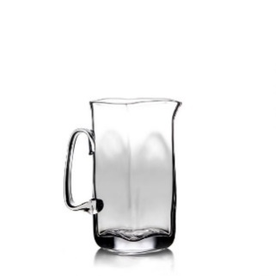
1 | 7360 | Simon Pearce Woodbury Chiller | 195 | PURCHASED
1 | 1235 | Simon Pearce Woodbury Bowl large | 235 | PURCHAPURCHASED
1 | 4110 | Simon Pearce Woodbury Square Pitcher & Sugar Bowl Set | 135 | PURCHASED
12 | 7381 | Juliska Berry & Thread Highball Glass | 32 | PURCHAPURCHASED
1 | 4207 | Simon Pearce Orleans Salad Servers | 79 | PURCHAPURCHASED
1 | 5428 | Simon Pearce Belmont Celadon Bowl Medium | 95 | PURCHASED
1 | 378 | Vietri Aladdin Brilliant Charcoal Gray Serving Spoon |  | 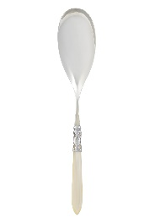
1 | 2021 | Vietri Aladdin Brilliant Charcoal Gray Slotted Serving Spoon | 41 | PURCHASED
1 | 377 | Vietri Aladdin Brilliant Charcoal Gray Serving Fork | 37 | PURCHASED
1 | 375 | Vietri Aladdin Brilliant Charcoal Gray Salad Server Set | 76 | 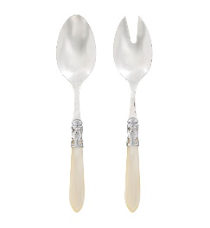
1 | 5447 | Vietri Florentine Gold Waste basket | 139 | PURCHAPURCHASED
1 |  | Andrew Pearce Walnut Echo 13” Bowl | 220 | 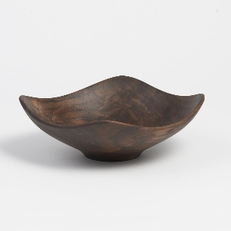
1 | 322 | Pewter Fox salt & pepper | 68 | PURCHASED
1 | 5308 | Charvet 71” square linen tablecloth | 124 | PURCHASED
1 | 7347 | Maple Leaf at Home Custom maple cutting board w/ wrought iron handles (To be ordered w/ monogram) | 162 | PURCHAPURCHASED

